Original folders in Nimbus | Those that arrived in Joplin
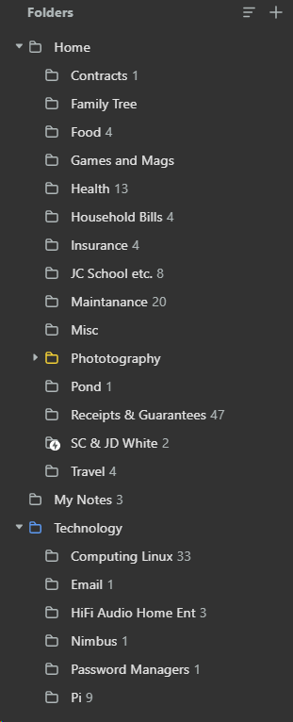 | 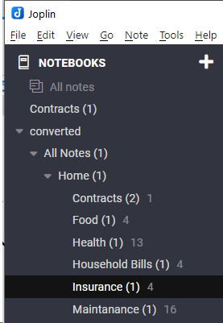
Original in Nimbus 1 | Example of one of the notes that transferred to Joplin
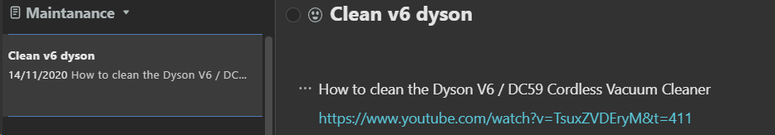 | 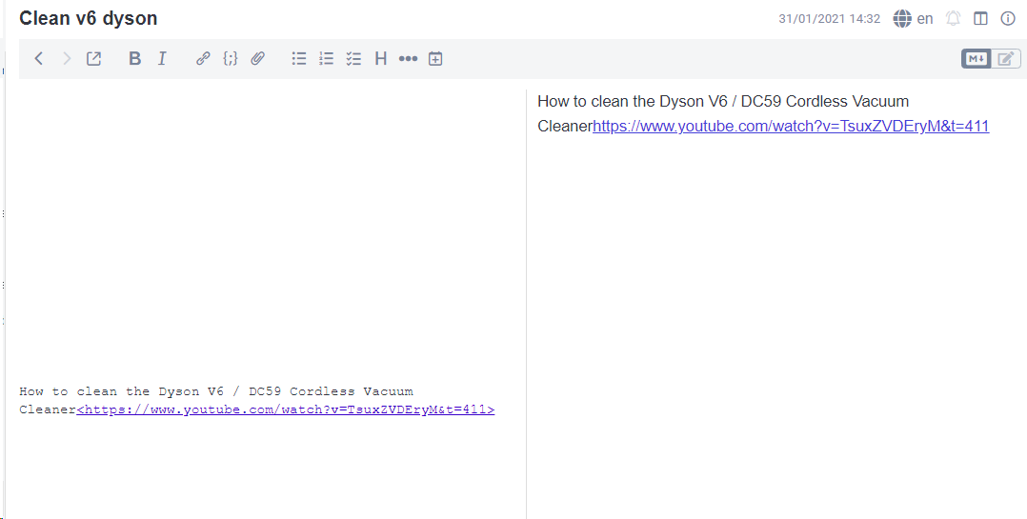
So this looks OK
Original in Nimbus 2 | Joplin
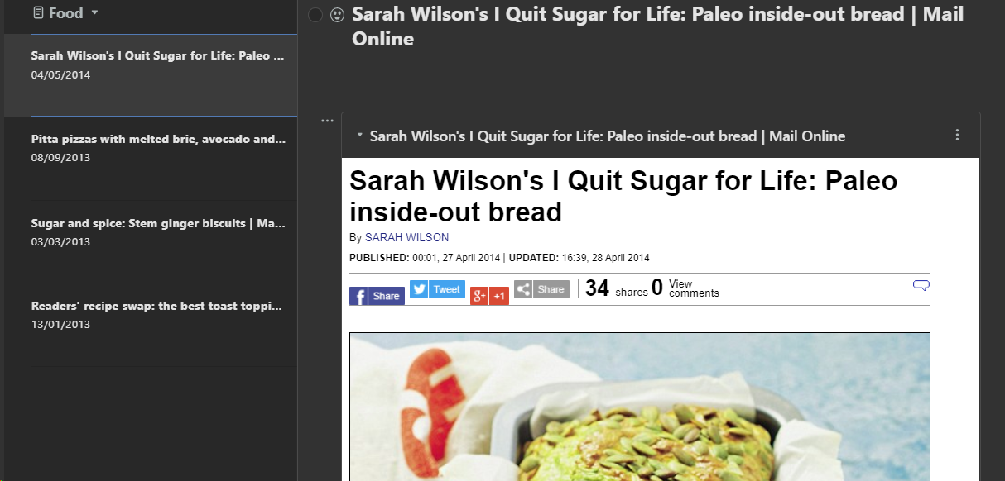
 | Only title appears.
Screenshot of folders converted | Export File structure
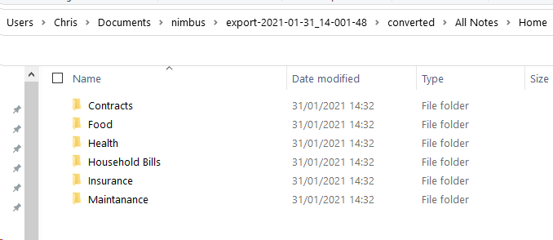 | 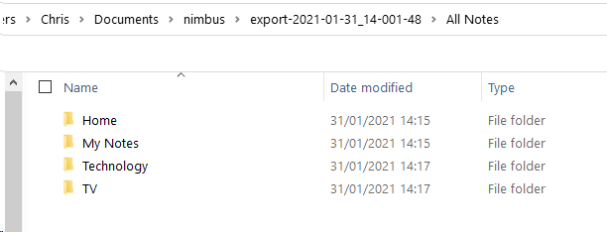
 | Maybe worth noting that the export from Nimbus was not zipped

